Answer Key:

1 Absolute Location
2 Relative Location
3 Formal Region
4 Functional Region
5 Perceptual Region
6 Physical Geography
7 Human Geography
8 Mercator Projection Map
9 Robinson Projection Map
10 Azimuthal Projection Map
11 Push Factor
12 Pull Factor

8.
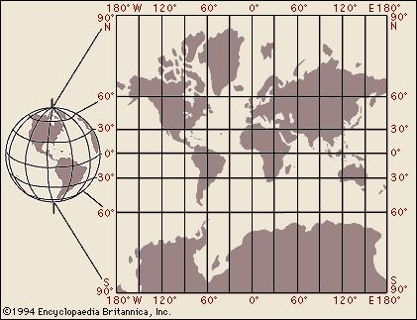

9.
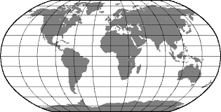

1. 29.4608° N, 95.0513° W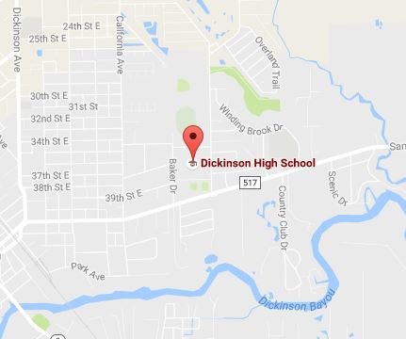

2. Dickinson is in between Galveston and Houston.
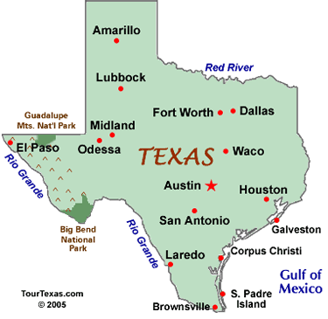

3. This is a _____________ region
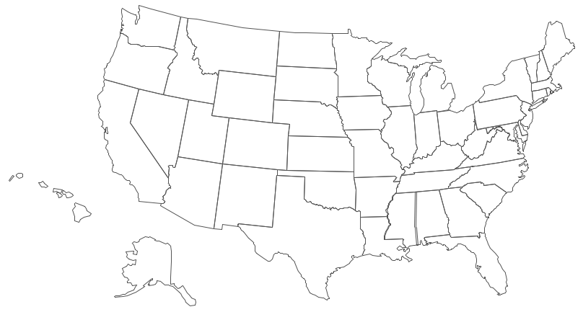
4. Delivery Radius of Dominos is a __________ region.
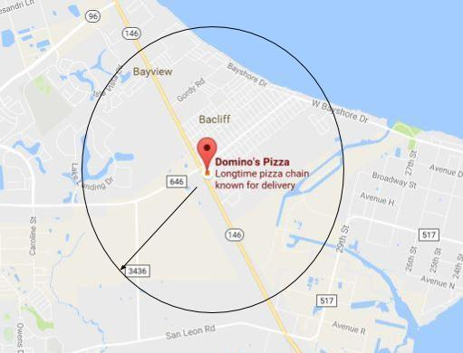
5. The Dirty South is known as a ______________ Region
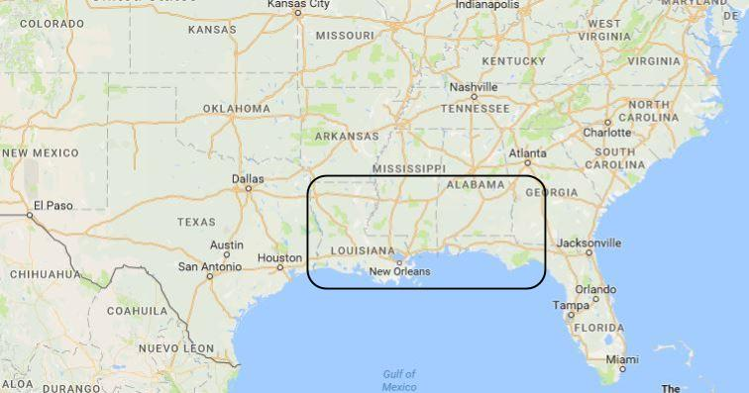

6. _____________ ________________ deals with processes and patterns that shape the natural world.

10.
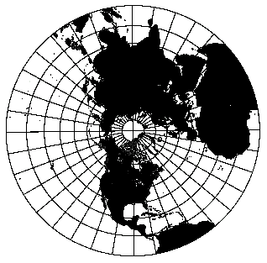
11. Drought, poor harvests, and poor housing are examples of ___________.
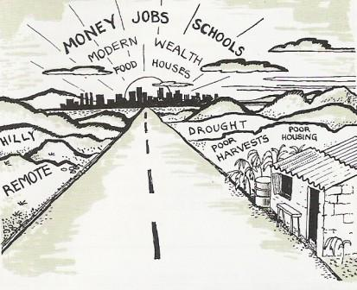
12. Jobs, wealth, and houses are examples of _________.

7. Which type of geography would include buildings, food, music, and religion.
